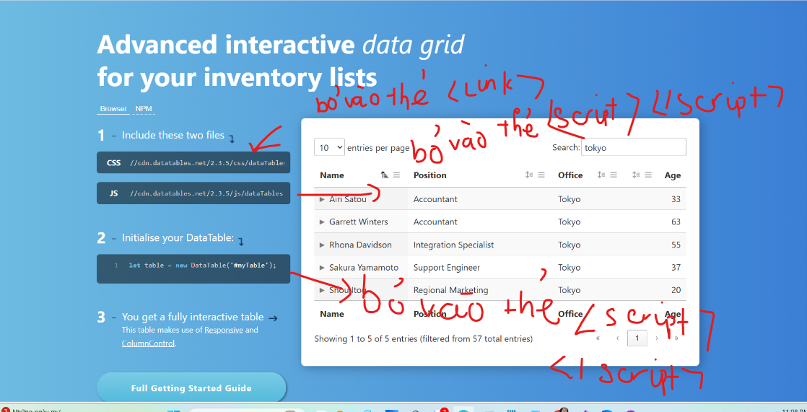

<link href="//cdn.datatables.net/2.3.5/css/dataTables.dataTables.min.css" rel="stylesheet">

<script src="//cdn.datatables.net/2.3.5/js/dataTables.min.js"></script>

<script>
let table = new DataTable('#myTable');

</script>

Views

@model List<TechLaptop.Models.ProductModel>

<a asp-action="Create" asp-controller="Product">Add Product</a>
<table class="table" id="myTable">
<thead>
<tr>
<th scope="col">#</th>
<th scope="col">Product Name</th>
<th scope="col">Product Description</th>
<th scope="col">Product Price</th>
<th scope="col">Product Image</th>
<th scope="col">Product Slug</th>
<th scope="col">Product Category</th>
<th scope="col">Product Brand</th>
<th scope="col">Product Manage</th>
</tr>
</tr>
</thead>
<tbody>
@foreach(var item in Model ){
<tr>
<td ></td>
<td></td>
<td></td>
<td></td>
<td> </td>
<td></td>
<td></td>
<td></td>
<td> </td>
</tr>
}

</tbody>
</table>

<partial name="_Paginate" model="@pager" />

@section Scripts {
<script>
let table = new DataTable('#myTable');

</script>
}

